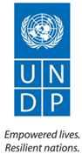
Towards Sustainable Solutions for Improved Living Conditions of Palestinian Refugees in Lebanon
A Joint UNDP / UN-HABiTAT Programme

REPORTING PERIOD: January – december 2012

Programme Title & Project Number |  |  | Country, Locality(s), Priority Area(s) / Strategic Results
- Programme Title: Towards Sustainable Solutions for Improved Living Conditions of Palestinian Refugees in Lebanon  - Programme Number: 0007183  - MPTF Office Project Reference Number: 00081985 |  |  | Country/Region: Lebanon
 |  |  | Priority area/ strategic results: Palestinian Gatherings (including Adjacent Areas of Palestinian Refugee Camps) in Lebanon)
Participating Organization(s) |  |  | Implementing Partners
- UNDP  - UN-HABITAT |  |  | - The Lebanese – Palestinian Dialogue Committee (LPDC)
Programme Cost (US$) |  |  | Programme Duration
JP Contribution from SDC (pass-through) : USD 1,000,000 |  |  | Overall Duration: 36 months
 |  |  | Start Date: 01/03/2012
Government Contribution  (if applicable) |  |  | Original End Date: 28/02/2015
Other Contributions (donors)  From NORCAP: USD 100,000 (salary & benefits) |  |  | Current End date: 28/02/2015
TOTAL: USD 1,388,500
Programme Assessment/Review/Mid-Term Eval. |  |  | Report Submitted By
Assessment/Review - if applicable please attach  Yes No Date: dd.mm.yyyy  Mid-Term Evaluation Report – if applicable please attach  Yes No Date: dd.mm.yyyy |  |  | - Name: Nancy Hilal  - Title: Project Manager  - Participating Organization (Lead): UNDP  - Email address: nancy.hilal@undp-lebprojects.org

List of Abbreviations and Acronyms

AA Adjacent Area
BUS Basic Urban Services
CSI Common Space Initiative

CDR Council of Development and Reconstruction

JP Joint Programmme
(I)NGO (International) Non-Governmental Organization

LPDC Lebanese – Palestinian Dialogue Committee
MOM Minutes of Meeting
MOU Memorandum of Understanding
MPTF Multi-Partner Trust Fund

PARD Popular Aid for Relief and Development

PC Popular Committee
PCP Participatory Community Plan
PU Premiere Urgence
SAA Standard Administrative Arrangement
SUDS Sustainable Urban Development Strategy
TOR Terms of References

UNDP United Nations Development Programmme

UN-HABITAT United Nations Human Settlements Programme

UNRWA United Nations Relief and Works Agency for Palestine Refugees in the Near East

WG Working Group
PART I: ANNUAL NARRATIVE REPORT

EXECUTIVE SUMMARY
This 2012 Consolidated Annual Progress Report under Joint Programme “Towards Sustainable Solutions for Improved Living Conditions of Palestinian Refugees in Lebanon” covers the period from 1 January to 31 December 2012. This report is in fulfillment of the reporting requirements set out in the Standard Administrative Arrangement (SAA) concluded with the Donors. In line with the Memorandum of Understanding (MOU) signed by Participating UN Organisations, the Annual Progress Report is consolidated based on information, data and financial statements submitted by Participating UN Organizations. It is neither an evaluation of the Joint Programme nor an assessment of the performance of the Participating UN Organizations. The report provides the Steering Committee with a comprehensive overview of achievements and challenges associated with the Joint Programme, enabling it to make strategic decisions and take corrective measures, where applicable.

One of the most significant achievements of the Joint Programme (JP) is the gained endorsement of the Lebanese Government represented by the Lebanese – Palestinian Dialogue Committee (LPDC), which constitutes the national partner of the Programme. Together with LPDC, the JP had succeeded to establish a National Observatory on Gatherings, which collects and generates knowledge and GIS based data on all gatherings in Lebanon in order to inform and guide national policy dialogue on improving living conditions Palestinian refugees in Lebanon. In this context, the JP and LPDC are coordinating with other initiatives promoting dialogue at the national level with the same objective to maximize impact. Under the National Observatory, the JP and LPDC have established the ‘Information Sharing Platform’ that include (I)NGOs working in the gatherings, also known as the Gatherings working Group, to create a database on main needs and implemented or planned interventions in the gatherings. The significance of this achievement at the national level lies in its sustainability, whereby LPDC will host the National Observatory and use it to guide policies at the national level and devise a well-coordinated strategy of interventions with NGOs in the gatherings.

At a more local level, the JP has succeeded in bringing together the municipalities and Palestinian representatives in Saida area to agree on a number of joint service interventions that would benefit both. In a first step of its kind, two municipalities will be responsible for implementing projects that target both Lebanese and Palestinian communities living within their domains. Another strategic initiative has started as a pilot in the Adjacent Areas of Ain el Helwe Camp, to develop a Participatory Community Plan and implement basic urban services and infrastructure projects to improve living conditions in these areas. In order to guarantee complementarities and coordination with concerned municipalities, consultations have been established with Saida Municipality in the context of its “Strategic Urban Development Strategy”. Lessons learnt from this initiative will guide its replication in other areas that accommodate for Palestinian gatherings in Lebanon, especially that the JP has finalized the delivery of training on local strategic planning to a total of twelve Unions of Municipalities reaching 300 participants.

The Multi-Partner Trust Fund Office (MPTF Office) of the United Nations Development Programme (UNDP) serves as the Administrative Agent of the Joint Programme. The MPTF Office receives, administers and manages contributions from Donors, and disburses these funds to the Participating UN Organizations in accordance with the decisions of the Steering Committee. The Administrative Agent receives and consolidates annual reports and submits to the Steering Committee.

This report is presented in two parts. Part I is the Annual Narrative Report and Part II is the 2012 Consolidated Financial Report.

Purpose
The main objective of the Joint Programme is to improve access to Basic Urban Services in Palestinian Gatherings (including Adjacent Areas of Palestinian Refugee Camps) in Lebanon (see map in Annex 1). Palestinian gatherings in Lebanon are generally excluded from basic urban services provided by public service agencies and municipalities in the surrounding areas or those provided by UNRWA, as per its mandate, in the camps. As an alternative mechanism, dwellers resort to a number of informal self-help initiatives to access and maintain BUS. Methods that are feasible to the dwellers are generally elementary, inadequate and unsustainable; and they occur without minimum consideration to environmental or engineering standards. Although these services and infrastructure networks are connected in an ad-hoc manner to the surrounding networks, no communication or coordination mechanisms exist between the key local actors in the gatherings and those in the concerned municipalities; a case which has contributed to a state of rising tensions between the neighboring communities. In order to address these issues, the Joint Programme aims at working in an integrated manner at both national and local levels to enhance access to BUS in the gatherings, focusing on the governance of these services and the relationships between various actors.

Joint Programme Outcome: Living conditions of the communities living in Palestinian gatherings (including Adjacent Areas of Palestinian Refugee Camps) improved, through enhanced access to basic urban services. During the first year, this outcome was planned to be achieved through a number of key strategic interventions, as per the Annual Work Plan of year 1 in the Project Document:

At the national level
- Establish a national observatory for gatherings;
- Produce a policy paper that would promote access to BUS in the gatherings;
At the local level
- Support the implementation and coordination of joint BUS projects between Lebanese and Palestinian communities;
In the Adjacent Areas
- Implement two strategic infrastructure projects in selected Adjacent Areas;
- Support local communities in the management and operation of implemented services;
At the municipal level
- Promote experience sharing among municipalities that accommodate for Palestinian gatherings within their domains;
- Assist selected municipalities develop local plans.

It is worth mentioning that the Joint Programme will contribute to the achievement of national priorities and international commitments. Through the UNDAF, the action is aligned with the programmatic area of priority related to socio-economic development and regional disparities, which states as an outcome that “by 2014, the socio-economic status of vulnerable groups and their access to sustainable livelihood opportunities and quality basic social services are improved within a coherent policy framework of reduction of regional disparities”. The project also contributes to reducing urban tensions and building bridges between the neighboring Lebanese and Palestinian communities through addressing the governance of access to basic urban services.

Results
- Narrative reporting on results:
- Outcomes:

Joint Programme Outcome: Living conditions of the communities living in Palestinian Gatherings (including Adjacent Areas of Palestinian Refugee Camps) improved, through enhanced access to basic urban services.

In a first step towards the realization of this outcome, the Joint Programme has gained the endorsement of the Lebanese – Palestinian Dialogue Committee (LPDC) as its national partner on behalf of the Lebanese Government. LPDC has shown commitment towards the objectives and activities agreed to be implemented within the context of this Joint Programme. Such political commitment represents a significant approach undertaken by the Government of Lebanon to enhance relationships with the Palestinian refugee community and improve their living condition in the hosting country. LPDC, through its role as a consultative inter-ministerial committee that gather official representatives from ministries and decision-makers at the national level, represents the optimal platform to advocate for enabling policies and for raising awareness on living conditions of Palestinian refugees in the country. This could contribute to dissolving some of the fears from the permanent resettlement of Palestinian refugees (tawtin) in Lebanon at a higher political level. According to LPDC:
“The UNDP/ UN-HABITAT project represents an opportunity for LPDC as it goes particularly in line with LPDC strategy for the coming year 2012. LPDC is looking forward to this project as leverage for its efforts in covering areas like Adjacent Areas of camps and gathering and more specifically into the creation of a National Database for the Palestinian presence in Lebanon. Later on, this would help in the formation of a National and regional strategies concerning these areas”.

In this context, LPDC has agreed to host on the long run the National Observatory for Gatherings established by the Joint Programme as knowledge generation and planning tool. Knowledge and data generated by the National Observatory will be used by LPDC, through and beyond the life span of the JP, to advocate for policies, and ultimately a national institutional framework, that would enable the improvement of living conditions of Palestinian refugees in Lebanon. Such initiative would serve to establish well informed policy discussions at the national level based on accurate data and indicators instead of assumptions and misconceptions. LPDC expects it to improve and strengthen the central government interaction with the Palestinian communities and critically enhance the state planning of future interventions. LPDC, with the support of the JP, has been coordinating the activities of the National Observatory with the Gatherings Working Group (WG). Chaired by LPDC, the Gatherings WG is a national platform that includes main international and national NGOs and organizations that work in Palestinian gatherings as well as UNRWA and is chaired by LPDC. Knowledge and data generated by the National Observatory will be used by the Gatherings WG to devise a well-coordinated strategy of interventions in the gatherings based on mapping of needs and corresponding projects.

Also in terms of national endorsement, the Joint Programme gained the endorsement of the Local Partner Appraisal Committee (LPAC), which included representatives from LPDC, the Ministry of Interior and Municipalities, the Council of Development and Reconstruction (CDR) and UNRWA. Feedback from these participants was taken into consideration into the final project document. The LPAC did not only achieved national endorsement of the project but also contributed to raising awareness and clearing misconception of public institutions on the status and state of living environment and access to BUS in Palestinian gatherings. In this context, UNRWA has expressed their commitment to facilitating advocacy efforts at the national level. The JP and UNRWA have agreed to coordinate all activities of the project not only at the national level but also at the more local level especially in the Adjacent Areas of the refugee camps.

At the more local level, a number of pilot initiatives, which could be learnt from and replicated, contribute to the achievement of the main outcome of the Joint Programmme. For this purpose, Adjacent Areas of Ain el Helwe Camp in Said area in South Lebanon is taken as a pilot. Ain el Helwe AAs and the surrounding were selected as a pilot for a number of reasons, most importantly:
- LPDC identifies Ain el Helwe Camp and AAs and their surrounding as it priority for 2013 given the worsened living and security situation;
- UNRWA is planning to carry out a Profiling and Camp Implement Plan in Ain el Helwe Camp and is currently implementing a WATSAN project in the camp, which requires coordination and connections with the AAs;
- Ain el Helwe AAs exhibit complex and diverse dynamics in terms of connections and relationships to the camp and the surrounding municipalities, which would enrich lessons identified for assessment and replication;
- Ain el Helwe AAs represent the largest Adjacent Areas in number, size and population;
- Living environment in Ain el Helwe AAs is considered the worst among other AAs.

In this context, the JP is undertaking an integrated approach that contributes to improving access and governance of basic urban services in Ain el Helwe AAs and their surroundings through:
- Developing a Participatory Community Plan (PCP): The PCP of Ain el Helwe AAs will guide the development of a number of projects and interventions that would improve the living environment in the AAs as well as coordination with surrounding municipalities and other concerned actors. This exercise will also include the concerned municipalities and other relevant institutions;
- Implementing infrastructure renewal and upgrading intervention: In parallel to the development of the PCP and to respond to urgent BUS needs and build trust with the local communities, urgent infrastructure projects were identified and validated with the local community for implementation.
- Promoting coordination between Lebanese and Palestinian actors: in order to promote the role of municipalities in upgrading and service provision in these AAs and to create coordination mechanisms between them and representatives of Palestinian communities, a number of joint BUS projects were agreed upon for implementation. These projects benefits neighboring or mixed Lebanese and Palestinian communities and will be implemented by the municipalities.
- Support the municipalities respond to challenges within their domains: Municipalities that accommodate for Ain el Helwe AAs as well as other Palestinian gatherings within their domain, namely Saida, Darb el Sim and Mieh Mieh received training on local strategic planning as part of the Union of municipalities of Saida and Zahrani. Moreover, a number of meetings and field visits were carried out with representatives of Palestinian communities to identify main problems and issues. Coordination is also ongoing with the Sustainable Urban Development Strategy led by the Municipality of Saida.

These integrated activities, in addition to similar interventions carried out in the Adjacent Area of Mieh Mieh and Beddawi Camp in South and North Lebanon respectively, will guide replication in other gatherings in Lebanon. Moreover, lessons learnt and knowledge will be transferred to the national level to benefit and inform policy discussions and the interventions of LPDC.

- Outputs:

Output 1: A national framework addressing the living conditions and access to basic urban services in the Palestinian informal gatherings (including Adjacent Areas) developed and implemented.

The main goal of output 1 is to enhance living conditions and access to Basic Urban Services in Palestinian gatherings (including Adjacent Areas) through creating a national institutional framework that enables and guides an upgraded and sustainable service delivery. This framework will be based on a number of nationally endorsed policies and strategies that would focus on the most pertinent areas or sectors. In order to facilitate this goal, clear and accurate information and data on living conditions and access to services in the gatherings will be compiled and shared with participating national key stakeholders. In this context, the establishment of a national observatory shall enable developing indicators, analyzing and monitoring living conditions in the gatherings and guiding policy discussions. Gender segregated data will be taken into consideration during this process. Targets as per the Annual Work Plan:
- Establish a national observatory for gatherings
- Produce a policy paper that would promote access to BUS in the gatherings

1.1 Knowledge base on Palestinian gatherings established through the National Observatory
With the beginning of the project, the team has launched consultations with LPDC and members of the Gatherings Working Group to gain endorsement of the National Observatory; consulted organizations agreed on the importance of such a tool for guiding interventions and future plans and for coordinating efforts among actors in the gatherings. As mentioned earlier, LPDC has agreed to host and coordinate activities of the National Observatory on the long run. Data produced will be used by LPDC and the JP in the process of national dialogue to develop policies that would enable access to adequate basic urban services for Palestinian refugees living in the gatherings in Lebanon.

For this purpose, the National Observatory aims at creating an Information Sharing Platform for the Gatherings to include members of the Gatherings WG (INGOS) but also local NGOs working in the gatherings and any other implementing organizations whether public or private. This platform will collect and provide data on the following information on gatherings:
1) Profile and overview;
2) Key needs;
3) Finished, on-going and planned projects and interventions; and
4) Relevant publications, web links or secondary data.
Data will be periodically generated and shared using on-line accessible system(s). A working paper of the Information Sharing Platform was developed together with LPDC and discussed during the Gatherings WG meeting that took place on 6 December 2012. Members of the gatherings WG agreed to form a smaller committee of focal points appointed by the WG members to follow-up on the Information Sharing Platform tasks. Members of the Information Sharing Platform will play a role in data generation, through reporting on their activities in the gatherings and sharing any studies or reports. The framework of the Information Sharing Platform is presented in Annex 3.
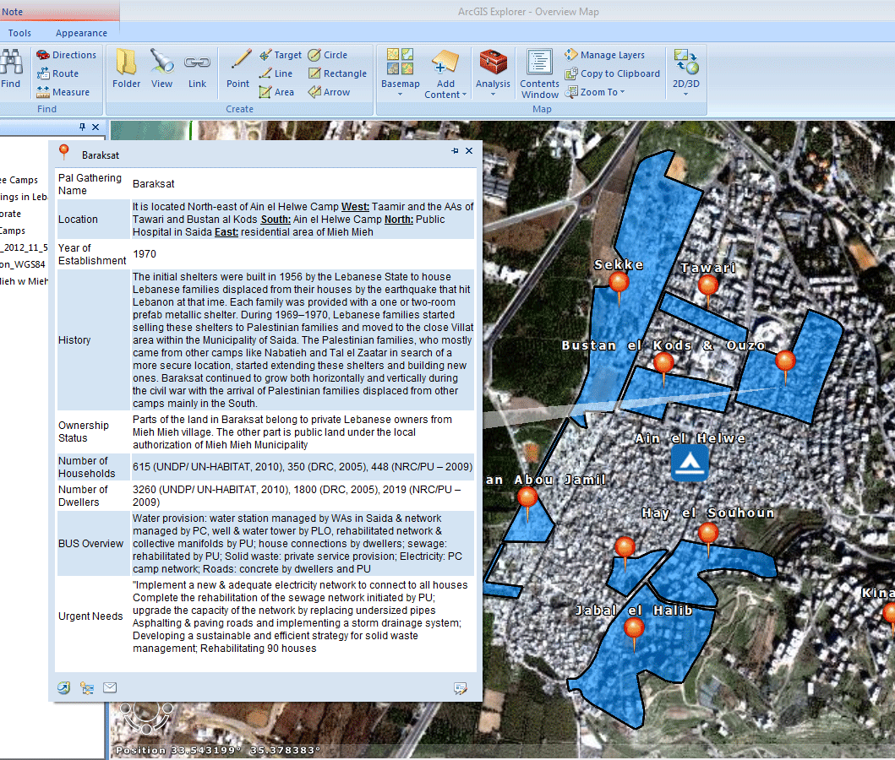
In order to create a structure for the data collected and generated, a GIS Database for Palestinian Gatherings was created. This geographic based data allows for locating the gatherings using an-online program (ArcGIS explorer) while providing the four categories of information upon clicking on the gathering. Data could be sorted sectorally or thematically and relevant reports, charts and graphs could be produced. In this context, coordination was established with UNRWA to complement its already existing Profiling System that covers the 12 Palestinian Refugee Camps in Lebanon. UNRWA has provided the Joint Programme with the indicators of the Profiling System; the JP in return has populated the indicators with available secondary data in the gatherings to produce the profile and overview of each gathering (including Adjacent Areas and the camps they surround).

To collect additional information to profile each gathering in Lebanon and identify the major needs in it, the JP will conduct data collection in the 42 gatherings in Lebanon distributed along Beirut, the North, South and Bekaa. This Gatherings Datasheet will be carried out jointly with The Popular Aid for Relief and Development (PARD), a local NGO that extensively works in the gatherings. A questionnaire has been developed to be filled by the team with the Popular Committee as well as by another group (women, youth, etc.) that PARD has established or has access to. Data will be collected along the following main fields:
▪ General overview ▪ Governance
▪ Population and Housing ▪ Income
▪ Health ▪ Education
▪ Social services ▪ Access to BUS methods & projects
▪ BUS and infrastructure needs ▪ All needs according to priorities
▪ Relationship with local authorities

Data on finished, on-going and planned projects will be collected and updated from the implementing organizations in the gatherings through filling a form that will be sent to them via emails. This form, known as the 3Ws (who’s doing what where) Matrix was created (using Access Program) and tested with PU, and training on access was delivered to staff members from the JP and LPDC to manage received data. The 3Ws matrix and example of its application into the GIS database are presented in Annex 4.

1.2 Dialogue on access to BUS in gatherings and AAs initiated with national and local stakeholders
The JP and LPDC carried out a series of stakeholders consultative meetings, hosted at LPDC, to discuss linkages and coordination between the local level initiatives and the central level national programming endeavours and to investigate the engagement of national and local actor. Five Stakeholders Consultative Meetings were organized by April 2012 with the following groups of stakeholders:
- Municipalities;
- INGOs and NGOs;
- Public Service Providers;
- Palestinian stakeholders and Popular Committees;
- and UNRWA officials and Camp Service Officers in relevant camps

The meetings resulted in the following outputs:
- Raise awareness, clarify misconceptions and share knowledge on living environment and access to BUS in the Adjacent Areas and gatherings;
- Collect participants’ feedback and establish dialogue on potential cooperation and coordination to serve the objectives of the Joint Programme and LPDC overall operational framework.
- 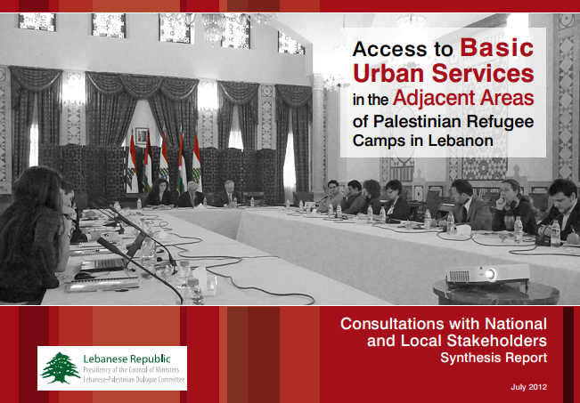Develop a list of recommendations that would allow for the improvement of access to BUS in the AAs and gatherings in general. These recommendations will be built upon to initiate policy consultations for improving access to BUS in Palestinian gatherings in Lebanon in the next phase. They could be summarized by the following:
- Commencing from a right-based approach;
- Adopting integrated approach to address access to BUS in AAs;
- Providing financial incentives for municipalities;
- Developing the role and capacities of Popular Committees;
- Clarifying interface of municipalities and public service providers in AAs;
- Documenting and building on experience and lessons learnt;
- Strengthening communication and operation channels.

A Synthesis Report on the Consultations with National and Local Stakeholders was published and shared with participants. The report focused on three main elements: 1) the Differing perspectives on the AAs by stakeholders; 2) potential roles played by each stakeholder; and 3) challenges to improved access to BUS in the gatherings and AAs.

Building on these consultations, the JP has been coordinating with LPDC and Common Space Initiative (CSI) a strategy for supporting national dialogue on improving access to Basic Urban for Palestinian refugees in Lebanon. As a basis for dialogue, research on the formal and informal mechanisms used to access BUS both in the camps (and their AAs) and gatherings will be designed.

Although the AWP targeted the production of a policy paper in year 1, a decision was taken by the JP and LPDC, based on recommendations from the latter, to postpone the development of policy paper until sufficient experiences and findings have been gained from the ground at the local level. This would ensure that the reality of needs and dynamics revealed from the gatherings guide the national discussions for a more informed and knowledge based dialogue.

Output 2: Collaborative mechanisms between Palestinian and Lebanese for improved service delivery strengthened and/or established in selected areas.

Output 2 aims at promoting dialogue and communication between Palestinian refugee communities and the Lebanese local authorities in areas that include Adjacent Areas, informal gatherings as well as refugee camps. For this purpose, a mapping of existing collaboration frameworks will allow for the strengthening or the establishing of such frameworks for implementing joint initiatives that would mainly enhance access to Basic Urban Services. UNDP and UN-HABITAT will provide necessary technical support, including coaching and assessments, throughout the process. Annual Target as per the Annual Work Plan:
- Support the implementation and coordination of joint BUS projects between Lebanese and Palestinian communities;

2.1 Coordination between Lebanese and Palestinian actors on joint BUS projects in Saida area
The two municipalities of Darb el Sim and Mieh Mieh accommodate for a number of Adjacent Areas (around Ain el Helwe and Mieh Mieh Camps) as well as gatherings within their domains. Although infrastructure networks are ultimately connected and the effects of improper basic urban services are adverse, no coordination exists between municipalities and Palestinian representatives in the gatherings and AAs. The two municipalities do not provide services or carry out infrastructure services in these areas. As part of its second output, the JP has brought together members of the municipality, popular or local committee, UNRWA camp officers and representatives of the Union of Palestinian Engineers in Saida area to discuss joint BUS projects that would benefit both Lebanese and Palestinian communities. As a result, the actors had agreed on a list of projects that require interventions in both Lebanese and Palestinian inhabited areas and would therefore require the engagement and coordinating of all actors. It is worth mentioning that members of the municipalities and Palestinian committees have not met before this initiative. In a step that is considered the first of its kind, the municipalities will be implementing projects in the gatherings and AAs. A joint committee formed of main local actors (municipality, Popular Committee, UNRWA officers) would agree on coordination mechanisms for the maintenance and the sustainability of interventions. This initiative would contribute to achieving the following impact:
- Encourage and empower the municipalities to engage in improvement projects in Palestinian gatherings and AAs;
- Enhance communication and relationships between municipalities and representatives of Palestinian communities living within the municipal boundaries
- Improve living conditions / environment for both Lebanese and Palestinian communities through implementing physical interventions and devising coordination and follow-up mechanisms

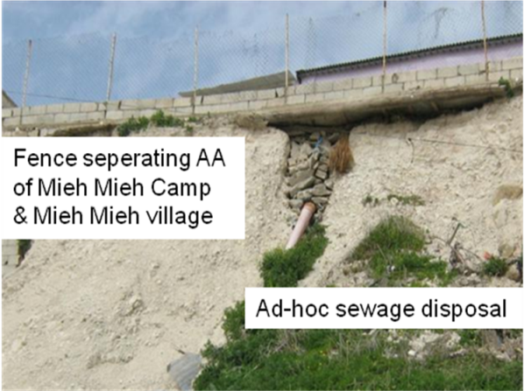
The joint projects implemented by Mieh Mieh municipality will target communities living in the village, AAs of Mieh Mieh Camp and Taamir which is a mixed Lebanese and Palestinian area. Projects include:
- Implementation of sewage and rain water disposal and retaining walls along the road leading to Mieh Mieh Camp and AA;
- Rehabilitation of sewage pipe and manhole between Mieh Mieh village and Mieh Mieh AA (see picture);
- Installation of public lighting on the streets in Taamir;
- Installation of solid waste containers.

The joint projects implemented by Darb el Sim municipality will target communities living in the village, Seerob gathering and Adjacent Area of Ain el Helwe Camp as well the camp itself (for more details, refer to the Specific Story in section iii). Projects include:
- Rehabilitation of sewage and rain water disposal line between Darb el Sim village, Seerob gathering in Darb el Sim and the entrance to Ain el Helwe Camp;
- Rehabilitation of sewage pipe and manhole between Darb el Sim village and Jabal el Halib Adjacent Area around Ain el Helwe Camp.

Concept notes, BOQs and illustartions of the projects were developed to assist municipalities initiate a call for proposal, which are attached in annex 5.

2.2 Participatory Community Mapping in Ain el Helwe AAs carried out
In order to understand dynamics, coordination mechanisms, relationships and main needs in Ain el Helwe AAs, local actors and stakeholders will be empowered to carry out a Participatory Mapping. Targeted communities will include Ain el Helwe Adjacent Areas and the concerned municipalities of Saida, Darb el Sim and Mieh Mieh. The mapping aims at understanding the underlying relationships and governance structures of the living environment with focus on access to BUS on the one hand and conflict drivers on the other. As such the mapping will be jointly carried out by the JP and the UNDP project ‘Strengthening Civil Peace in Lebanon”. The mapping will focus on two main interconnected areas:
a) The living environment with focus on access to BUS
b) Conflict dynamics, peace assets, interaction patterns
The approach shall be of participatory nature, as representatives of all stakeholders in Ain el Helwe AAs and the concerned local authorities will be involved in assessing diverse needs at the local level and in identifying local capacities and resources for addressing these needs. The mapping will also support the identification of key priorities and recommendations for improving the living environment in the AAs and for enhancing relationships internally and with the surrounding Lebanese communities. The results of the mapping will be later used to support local communities develop an improvement plan or a ‘Participatory Community Plan’ for Ain el Helwe AAs. A Stakeholders Analysis was carried out by the JP to map local NGOs that could be involved in the implementation of the process; as a result PARD was selected. The Terms of References (TOR) was developed to hire a consultant to design the exercise (see Annex 6).

2.3 Joint Lebanese – Palestinian Committee in Beddawi supported to consume its role
In preparation of strengthening coordination mechanisms between Lebanese and Palestinians in Beddawi, the JP has carried out meetings with the different stakeholders to gain knowledge about their main needs and priorities in the area. Meetings were held with the Popular Committee in Beddawi Camp (including representatives of the AAs), the Municipality of Beddawi and UNRWA office in the camp MoM attached in Annex 7). The municipality and the PC recommended building on the Joint Committee formed by UNDP in the context of the MDGF project, which brought Lebanese and Palestinian actors together to carry out joint activities. It was agreed with local stakeholders that a joint meeting will take place to discuss how to strengthen the role of this Joint Committee and the type of joint interventions that could be carried out.

Output 3: Access and management of basic urban services in the Adjacent Areas improved.

Output 3 constitutes the hardware component of the project and aims at improving access to Basic Urban Services in the Adjacent Areas through upgrading projects, the implementation of service delivery interventions and the rehabilitation of infrastructure networks. In order to identify potential projects, the JP will conduct field work in collaboration and consultation with the local community representatives to identify/validate needs and priorities and guide the selection of the physical rehabilitation projects. Special attention will be given to including women and youth in these meetings. In order to guarantee the sustainability of results, selected community representatives will be trained to operate, manage and maintain implemented services and networks. In addition, awareness campaigns will target residents (including women) on viable approaches to access and improve the management of BUS. Targets as per the Annual Work Plan:
- Implement two strategic infrastructure projects in selected Adjacent Areas;
- Support local communities in the management and operation of implemented services;

3.1 Improved access to adequate sewage network in Muhajjarin AA, Beddawi
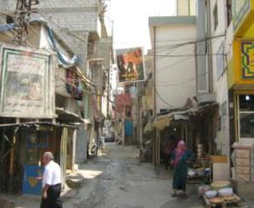
The local community in Muhajjarin suffers from sewage overflows due to inadequate sewage network. To address this problem, the JP will implement a project that includes: renewal of main sewage network, secondary connections, water channel and concrete layer to cover the width of the street. The required works will contribute to the project objective through improving the state of infrastructure network, in this case sewage, and dwellers’ access to the service in Muhajjarin AA. A call for offers was posted on line to start a competitive for small local contractors from the area, representing a unique case of directly contracting Palestinian contractors form the local community. The TOR is attached in Annex 8.

Prior to implementing this intervention, the project team met with representatives of the local community in Muhajjarin as well as with other relevant stakeholders to validate and agree on the intervention. These include representatives of the Neighborhood Committee and notable residents in Muhajjarin and the Popular Committee in Beddawi. The Neighborhood Committee in Muhajjarin undertakes interventions in the field of infrastructure and basic urban services mainly for maintenance and repairs of networks. Other local actors and stakeholders were also consulted such as the Municipality of Beddawi and UNRWA office in the North and in Beddawi. A follow-up local committee constituted of the previously mentioned actors will be formed to follow up on the implementation of the project and to agree on future maintenance of the sewage network.

3.2 Local communities in Ain el Helwe AAs supported to develop a Participatory Community Plan
In order to enhance access to BUS as well as living conditions in Ain el Helwe AAs based on consensus building and strategic thinking, an agreement was reached with the local community to develop a Participatory Community Plan (PCP). This PCP will be built as a continuation on the findings and recommendations of the Participatory Needs Assessment. This activity will be done through working groups and discussion meetings among key actors. The improvement plan will include an action plan with a list of the projects and interventions to be implemented, including their implementation and funding plans and capacity building sessions. The main objectives of carrying out the Participatory Community Planning for Ain el Helwe Adjacent Areas are the following:
- Assist local communities identify their emerging needs and priority areas of intervention;
- Establish communication and dialogue between local communities and their representatives in Ain el Helwe AAs and the concerned local authorities on areas of common interest;
- Empower the local communities to take the lead in the decision-making process to promote the development and peace building in their neighborhoods/areas;
- Strengthen the capacities of local stakeholders (CBOs, NGOs, Popular Committees, municipalities ….) and engage them actively in the entire process;

Such an intervention would provide a solid base for consolidating lessons learnt and best practices to enable its replication in other areas in Lebanon.
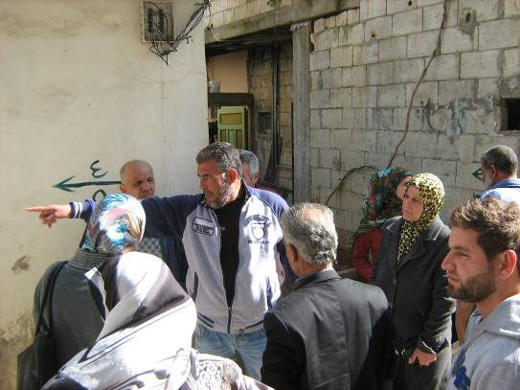
3.3 Urgent infrastructure projects identified in Ain el Helwe AAs for implementation
In parallel to developing a Participatory Community Plan, the JP will implement infrastructure and BUS projects in Ain el Helwe AAs to address urgent needs. For this purpose, the JP has been carrying out meetings with representatives of committees in Ain el Helwe Camp and AAs as well as with UNRWA officials to develop a list of urgent upgrading interventions needed in the AAs, based on pre-identified criteria. This list was validated with representatives of the local community. The result is a list of narrowed down projects based on feasibility and priority, which will be technically assessed for implementation in the eight AAs. Urgent projects are presented in Annex 9 per AA and priority.

Output 4: Selected municipalities are better equipped to engage in the improvement of living conditions in the gatherings and Adjacent Areas.

Output 4 addresses the municipalities that include gatherings and Adjacent Areas within their boundaries and aims at bridging the urban divide and promoting inclusive governance and development at the local level. For this purpose, capacity building programmes will be designed, according to local needs, to enhance municipal competence in inclusive planning approaches and local development strategies, which would include the gatherings and/or Adjacent Areas. Selected municipalities will be further assisted to produce local development plans. Annual Targets as per the Annual Work Plan:
- Promote experience sharing among municipalities that accommodate for Palestinian gatherings within their domains;
- Train municipalities on local strategic planning and support production of plans

4.1 Experience sharing initiated among municipalities that accommodate for gatherings and AAs
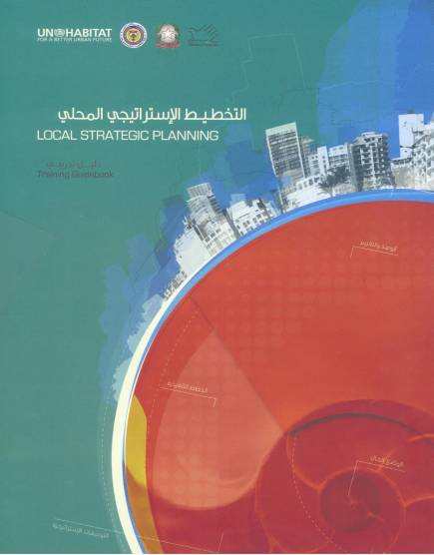
As part of the stakeholders consultation with national and local actors, a session included representatives of the municipalities that accommodate for gatherings and AAs. In order to share knowledge on successful examples of municipalities engaged in improving living conditions and particularly access to BUS in Palestinian gatherings, the case of Ghoberiy municipality was selected. Ghobeiry Municipality has implemented a number of BUS projects (including electricity and solid waste collection) in the gatherings of Sabra in Beirut, through donor funds. The experience was shared with the municipalities in the consultations by the Vice President in Ghobeiry Municipality. Discussion took place on the main challenges that currently face municipal interventions in Palestinian gatherings and AAs. The neighboring municipalities agreed that their provision of BUS in the gatherings is conditioned by: availability of financial resources, and cooperation with the popular committees in the camps and other committees. On the one hand, financial incentives to facilitate the municipality interventions were suggested to be through funds from the central Government or individual incentives. Moreover, other strategies to overcome the issue of funding include encouraging municipalities to out-reach and communicate with funding agencies, allowing big municipalities to help smaller municipalities in reaching out to donors and, allocating a specific item in the budget from the Independent Municipal Fund to cover service provision in the gatherings and AAs. The facilitation guide of this meeting is presented in Annex 10.

4.2 Capacities of municipalities enhanced on local strategic planning
As part of its wide experience in planning approaches, UN-HABITAT has developed a training toolkit on “Local Strategic Planning” and training of trainers (ToT) was carried out. The toolkit was jointly prepared by UN-HABITAT and the Directorate General of Municipalities and in consultation with an array of stakeholders, aims at empowering local authorities in Lebanon and to allow them address in a strategic manner the increasingly complex issues related to rapid and uncontrolled urbanization. Municipalities including gatherings and AAs in Saida area and Baalbak received training on local strategic planning as part of a wider training that targeted 12 Unions of Municipalities in Lebanon.

4.3 Coordination with Saida Municipality initiated on local planning
The JP has established the ground for cooperation with Saida Municipality at two main levels: 1) providing technical support to enable the municipality face urban challenges; and 2) assisting the municipality develop and follow up on the Sustainable Urban Development Strategy (SUDS) of Saida, an infinitive undertaken by the municipality as part of MEDcities project. The main objectives of cooperation with Saida Municipality are to promote approaches to inclusive local planning and to enhance participation of local Palestinian communities in the camps, AAs and gatherings within Saida. The JP has met with representatives of popular and local committees in Ain el Helwe Camp and AAs, who agreed on main coordination fields that need ot be discussed with the municipality. The JP also held a number of coordination meetings with the municipality, SUDS Project Manager and the team of local consultants recruited to develop the Strategy. Minutes of Meetings (MoMs) including the main areas of cooperation has been drafted and shared with the municipality (see Annex 11). In addition, the JP will support the Municipality of Saida equip an office space within the municipality for multi-purpose functions. It should be mentioned that this component has been delayed due to two main reasons: delays by the municipality to kick off its Sustainable Urban Development Strategy and assemble the team of local consultants and extensive time taken by the municipality to review MoMs and provide feedback.

- Delays in implementation, challenges, lessons learned and best practices
Due to the joint UNDP / UN-HABITAT decision to change the funding modality for the SDC contribution from the cost-sharing mechanism to the pass-through fund management mechanism and the subsequent formalization of the necessary legal agreements (which was completed in March 2012), the project faced some delays in its initial stage. This decision was made in order to benefit from the many advantages of the UNDG pass-through mechanism, specifically the pass-through mechanism allows a clear reduction in transaction costs when it comes to legal arrangements, administration and monitoring. For such modality, the UNDP Multi-Partner Trust Fund Office (MPTF Office) has been appointed as the Administrative Agent for the Joint Programme. The pass-through funding mechanism is governed by the standard Memorandum of Understanding (MOU), signed among the Participating UN Organizations and the MPTF Office, and a Standard Administrative Arrangement (SAA) signed between the donor and the MPTF Office. After consultations with its cooperation office in Beirut, SDC Headquarter agreed to use the pass-through funding modality and signed the SAA. As such, a revised Programme Document was introduced, the SAA was signed and the funding was rechanneled to the pass-through modality. Following the receipt of funds, three projects staff (project manager, GIS expert, administrative and finance assistant) were recruited in July 2012 and a field coordinator was recruited in September 2012. The time required to recruit the essential staff has delayed some targets set for the first year namely the production of a policy paper at the national level; completion of two infrastructure projects in selected AAs and assisting two municipalities to develop local plans.

In addition, the occurrence of some armed conflicts had compelled the JP staff to postpone some activities or visits mainly to Ain el Helwe AAs in the South and to Beddawi in the North. Close and continuous coordination with the popular and local committees in these areas is ensured to avoid any risky situations. In some cases and through coordination with the committees the project staff rescheduled the visits when necessary. In order to mitigate risks resulting from worsened security situation mainly around Ain el Helwe Camp, the Joint Programme has been working to establish contacts with the responsible committees in all the gatherings in Lebanon and carry out a rapid needs profile in these gatherings. This would allow for geographic expansion of activities in case of clashes or conflicts in one or more area.

- Qualitative assessment
Overall, the Joint Programme has successfully contributed to increasing knowledge base on Palestinian gatherings in Lebanon, through the establishment of the national observatory and networking with other actors and groups. This has led to raise awareness, increase knowledge and provide accurate information on the reality of access to basic urban services in the gatherings and Adjacent Areas. This has contributed to correcting misconceptions at both national and local levels about services provision in these areas, such as the assumption that UNRWA is responsible for service provision. Serving the same purpose at a more local level, channels for communication and coordination has been established, in some cases for the first time, between local authorities and Palestinian communities, leading to improvement in access to services and relationships.

The active engagement of key partners has contributed to the achievement of the JP results and to maximizing the effectiveness of interventions. The main contribution of each partner could be summarized by the following ongoing results:

LPDC
- Providing a national umbrella for the JP which encouraged participation and cooperation of actors
- Enabling a more comprehensive approach to enhancing living condition of Palestinian refugees in Lebanon through coordination with other interventions (by UNRWA, CSI, etc.)
- Coordinating the extension of knowledge in the camp to gatherings (such as UNRWA Camp Profiling System)

UNRWA
- Providing technical expertise on field for assessment of interventions and advise
- Providing knowledge on connections of services between the camps and AAs
- Coordinating with the JP to ensure proper linkages of services between the camp and AAs

General Secretary of Popular Committees (PCs) in Lebanon
- Facilitating networking with PCs in the gatherings in Lebanon
- Providing knowledge on main needs of PCs to engage properly in the JP
- Encouraging PCs to cooperate under the umbrella of the JP

Local and International NGOs
- Sharing knowledge and data on the gatherings
- Partnering in implementation (such as PARD, PU).

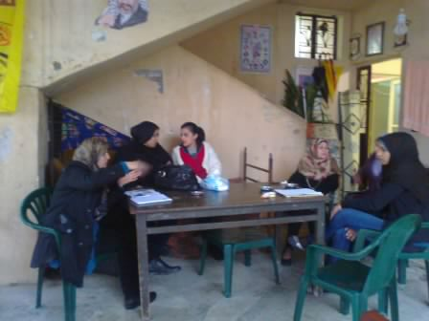
Throughout the planning and implementation of the Joint Programme, particular emphasis is being paid to mainstreaming gender issues within its various key components. For example, women are encouraged to participate in meetings the JP carries out in gatherings. Where formed, the JP makes sure to meet with women committees in the gatherings and AAs; similarly for youth. In addition, the national observatory will produce gender segregated data to further assess access to basic urban services for women, with a view to guiding policy discussions at the national level and the design of the local level initiatives. Furthermore, main activities of the JP are designed and implemented taking into account conflict sensitive principles. To this end, the JP is carrying the Participatory Mapping in Ain el Helwe AAs, an area widely affected by conflict. The support that the JP will provide to consensus building and policy dialogue will primarily focus on the provision of process design and the generation of joint knowledge which will assist with the identification of common ground among the key concerned stakeholders.

ii) Indicator Based Performance Assessment:

 | Achieved Indicator Targets | Reasons for Variance with Planned Target (if any) | Source of Verification
Outcome: Living conditions of communities living in informal gatherings (including Adjacent Areas of Palestinian Camps) improved through enhanced access to basic urban services  Indicators:  - National framework for addressing the living conditions and access to basic services in Palestinian informal gathering and adjacent areas developed and implemented  - Collaborative mechanisms between Palestinian and Lebanese for improved service delivery established  - Access and management of basic urban services in selected Adjacent Areas improved.  - Selected municipalities better able to respond to issues in gatherings / Adjacent.  Baseline:  Inadequate living conditions of communities living in informal gatherings and Adjacent Areas.  Planned Target:  Improved access to basic urban services in the gatherings | - Established a national observatory for gatherings to guide knowledge based dialogue and ensure cooperation among involved actors  - Supported the implementation and coordination of joint BUS projects between Lebanese and Palestinian communities (2 projects in Saida area, South Lebanon)  - Implemented infrastructure project in Beddawi Adjacent Area and prioritize projects in Ain el Helwe AAs  - Shared experience among municipalities that include gatherings |  | - Endorsement letter from LPDC  - Report “Access to Basic Urban Services in the Adjacent Areas of Palestinian Refugee Camps in Lebanon: Consultative Meetings with National and Local Stakeholders”  - GIS database on gatherings (ArcGIS viewer)  - Documents and studies of joint BUS projects for municipalities and infrastructure projects n the AAs  - Training toolkit on “Local Strategic Planning”
Output 1: A national framework addressing the living conditions and access to basic urban services in the Palestinian informal gatherings (including Adjacent Areas) developed and implemented  Indicators:  - # of policy papers developed and discussed with relevant central government agencies.  - National indicators to monitor living conditions of Palestinian refugees living in informal gatherings (including Adjacent Areas) established and data produced.  - # of consultative sessions held with Lebanese and Palestinian stakeholders to build consensus on proposed policy options  - Approval of the national framework by relevant national agencies obtained  - Action plans developed for the implementation of the national framework.  Baseline: Lack of enabling policies to support national and local level engagement in informal gatherings (including Adjacent Areas).  Planned Targets:  - Establish a national observatory for gatherings;  - Produce a policy paper that would promote access to BUS in the gatherings; | - Established and maintain knowledge base on access to basic services in the informal gatherings (including Adjacent Areas) through the establishment of a national observatory  - LPDC endorsed and agreed to host the National Observatory  - Created GIS database on gatherings  - Created Information Sharing Platform for knowledge generation and sharing among organizations working in the gatherings  - Initiated with PARD collection of data to profile gatherings and present key needs  - Carried out Consultative Meetings with National and Local Stakeholders under the leadership of LPDC | Decision was taken based on recommendation from LPDC to postpone the development of policy paper till year 2, until sufficient knowledge and information have been from the ground at the local level. | - Framework of Information Sharing Platform for knowledge generation and sharing among organizations working in gatherings (approved by members of Gatherings WG)  - indicators on gatherings within the GIS database of the National Observatory  - 3Ws Matrix  - Report “Access to Basic Urban Services in the Adjacent Areas of Palestinian Refugee Camps in Lebanon: Consultative Meetings with National and Local Stakeholders”  - Gatherings Datasheet / questionnaire
Output 2:  Indicators:  - Analysis of existing collaborative mechanisms between Palestinian and Lebanese produced.  - # of collaborative mechanisms established.  - # of joint initiatives implemented  - Action plans to initiate and/or sustain collaborative mechanisms developed.  - # of joint sessions held gathering concerned local stakeholders and national authorities (including LPDC)  - Best practices documented and disseminated at the national level.  Baseline: Absence of collaborative mechanisms for improved service delivery.  Planned Target:  - Support the implementation and coordination of joint BUS projects between Lebanese and Palestinian communities; | - Carried out Participatory Community Mapping in Ain el Helwe AAs to study existing mechanisms of interaction and analyze issues and concerns of relevant Palestinian and Lebanese stakeholders  - Established consensus on joint BUS projects in Darb el Sim and Mieh Mieh that target both Lebanese and Palestinian communities  - Empowered municipalities to implement the joint BUS projects  - Supported the joint Lebanese / Palestinian committee in Beddawi resume its role |  | - TOR Participatory Community Mapping exercise  - Concept notes and engineering studies of the projects  - MoM with local actors in Beddawi
Output 3: Access and management of basic urban services in Adjacent Areas improved.  - Indicators: # of infrastructure projects completed in selected Adjacent Areas;  - Community based plans for operating and maintaining basic urban services developed and in use by the local communities;  - Decreasing use of ad-hoc and haphazard methods to access basic urban services by the communities.  Baseline: Inadequate basic urban services in Adjacent Areas.  Planned Target:  - Implement two strategic infrastructure projects in selected Adjacent Areas;  - Support local communities in the management and operation of implemented services | - Implemented sewage renewal project in Muhajjarin AA – Beddawi, North Lebanon  - Identified list of urgent infrastructure projects in the eight AAs of Ain el Helwe Camp with local community  - Built consensus on developing Participatory Community Plan with local communities in Ain el Helwe AAs |  | - TOR and BOQ of sewage project in Muhajjarin  - List of urgent infrastructure projects in the eight AAs of Ain el Helwe Camp  Framework of Participatory Community Plan in Ain el Helwe AAs
Output 4: Selected municipalities are better equipped to engage in the improvement of living conditions in the gatherings and Adjacent Areas.  Indicators:  - Platform bringing together various municipalities created for experience sharing and outreach  - # of coordination meetings facilitated by selected municipalities  - # of integrated plans developed by selected municipalities.  Baseline: Limited municipal capacity, resources and know-how to respond to the issues faced by the Adjacent Areas.  Planned Target:  At the municipal level  - Promote experience sharing among municipalities that accommodate for Palestinian gatherings within their domains;  - Assist selected municipalities develop local plans | - Trained municipalities on concepts and approach of local strategic planning  - Initiated experience sharing among municipalities that accommodate for gatherings and Adjacent Areas.  - Initiated discussion on coordination with Saida Municipality |  | - ‘Local Strategic Planning’ toolkit  - Training on ‘Local Strategic Planning’  - MoMs with Saida Municipality  - Facilitation guide of meetings with municipalities

iii) A Specific Story

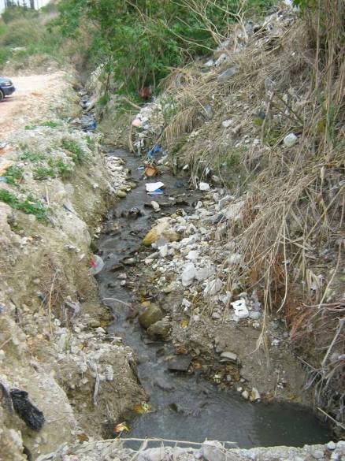
Problem / Challenge faced: Located in the village of Darb el Sim in South Lebanon between a Palestinian gathering ‘Seerob’ and the entrance to Ain el Helwe Camp, untreated sewage mixes with rain water in an open natural channel, causing environmental risks to neighboring Lebanese and Palestinian communities alike. In winter, heavy rains causes the flooding of untreated sewage from Darb el Sim village to the lower Ain el Helwe Camp and AA. In line with the general situation in Lebanon, the lack of communication and coordination mechanisms for service delivery between representatives of the Palestinian communities living in the gathering and camp on the one hand and the municipality of Darb el Sim on the other has hindered solutions to this problem. As an alternative, the Palestinian communities resorted to digging a ditch at the entrance of the camp to prevent sewage from entering, which caused reverse flooding into the surrounding lands in Darb el Sim. In addition to being a source of environmental risk, the situation contributed to raising tensions between the neighboring communities and with the local authorities.

Programme Interventions: The Joint Programme identified the problem through meetings with each group of local actors. In order to enable intervention, the JP organized a meeting between the mayor, representatives of popular committees in Seerob and Ain el Helwe Camp and UNRWA field officers, which was followed by field visit. Participants agreed that such a critical situation required immediate action, although none of the actors possessed sufficient financial resources. Consensus was reached that the Municipality would implement a project to rehabilitate the sewage and rain water channel, in coordination with UNRWA and the local committees. In order to support the municipality, the JP will provide a grant to cover the project costs as well as technical engineering capacities to develop studies and carry out the bidding process.
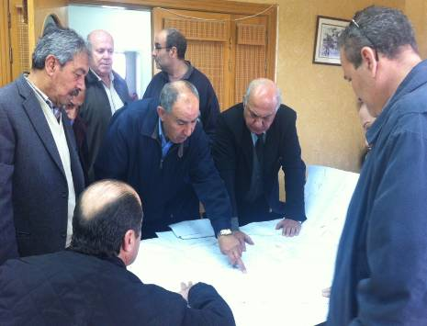
Result: The intervention resulted in enhanced communication and coordination between actors, which did not exist before. It also promoted municipal intervention in Palestinian gatherings.

Lessons Learned: building consensus and coordination on concrete interventions that constitutes a common need and priority facilitates building bridges and relationships between two communities.

IV. Programmatic Revisions
As mentioned earlier, a decision was taken by the JP and LPDC, based on recommendations from the latter, to postpone the development of policy paper till year 2, until sufficient knowledge and information have been from the ground at the local level.

V. Resources
Efforts to mobilize additional resources for the Joint Programme to support the full implementation of this initiaitve are ongoing. UNDP and UN-HABITAT have met with representatives from a number of donors, including, Canada, Norway, Italy, Austria and Finland, following the organization of a donor roundtable at the end of February 2012. Several donors, in particular Italy, EC, Finland and Austria have expressed interest in the project. Some of these interests have already translated into concrete partnerships such as with Italy and Norway. The JP and LPDC have been most recently discussing a joint fund mobilization strategy. In the next stage, individual meetings with a wide array of donors will be carried out jointly by the JP and LPDC, followed by a donor meeting in the Serail (refer to Annex 12).

The Joint Programme has the potential of increasing fund mobilization through its coordination with the Gatherings Working Group. This coordination provides the opportunity to create partnerships with other NGOs in the framework of the JP. In this regard, the JP is dicussing cooperation with Premiere Urgence (PU) to renew the sewage and water netwroks in Tawari AA, which are located aorund Ain el Helwe Camp in South Lebanon.

Strategic Results, as formulated in the Strategic UN Planning Framework (e.g. UNDAF) or project document;
The JP Contribution, refers to the amount transferred to the Participating UN Organizations, which is available on the MPTF Office GATEWAY
As per approval of the original project document by the relevant decision-making body/Steering Committee.
If there has been an extension, then the revised, approved end date should be reflected here. If there has been no extension approved, then the current end date is the same as the original end date. The end date is the same as the operational closure date which is when all activities for which a Participating Organization is responsible under an approved MPTF / JP have been completed. As per the MOU, agencies are to notify the MPTF Office when a programme completes its operational activities.
Basic urban services in this context include the sectors of water, sewerage, solid waste collection, electricity, road networks.
Find attached a letter of support from LPDC to other national actors in Annex 2.
The Common Space Initiative for Shared Knowledge and Consensus Building is a Lebanese independent initiative that facilitates structured dialogues among policy makers, intellectuals, experts and civil society actors to create an environment that is conducive to national evolution. It has established in 2011 the Lebanese – Palestinian Dialogue Forum.
Saida SUDS is part of the MEDcities project in twinning with the two cities of Larnaka in Cyprus and Soussa in Tunis; it’s a two-year project that will cover not only Saida but also its immediate surrounding villages.
The first and foremost is the reduction of transaction costs for the donor and agencies. For donors wishing to contribute to a Programme implemented by different UN Agencies, the mechanism allows to send one fund disbursement to one Agency instead of sending contributions to each UN Agency. When it comes to reporting, instead of receiving multiple reports on separate parts of the programme, the donors receive consolidated, holistic reports covering the achievements of the entire programme.

